Seated Exercise
Browns Court , Atkinson Road, Ashby LE65 2LZ
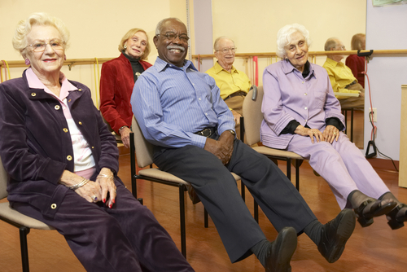
Every Friday
3pm – 4pm
7th September - 23rd November 2018
£3 per session or 12 weeks for £30

These classes are a fun way to improve flexibility, strength & balance. Come along, join in & make new friends! Classes led by Danny
To book a place please contact Rachel Hudson on:
01530 454558 Or Just Come Along!

